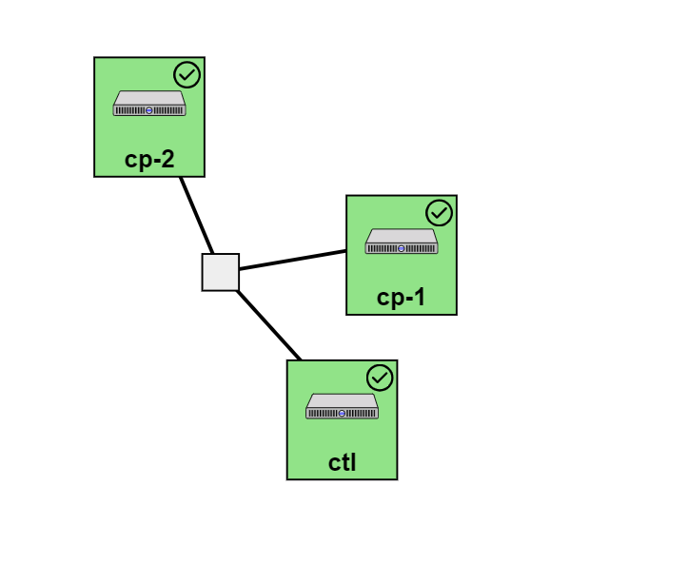

cp-1: install docker

cp-2: install apache

We will install docker on cp-1 and apache on cp-2